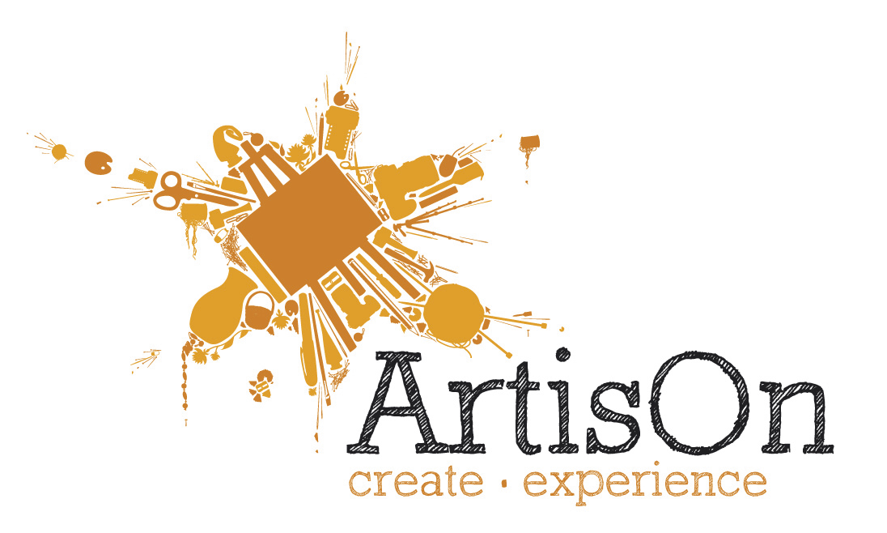
ArtisOn provides an unrivalled choice of short art and craft skills workshops in Masham, in the Yorkshire Dales. You can treat yourself to anything from painting to stained glass, from blacksmithing to crocheting, from ceramics to jewellery-making. Enjoy some “you time” or come with friends for a day of catching up, creating and enjoying a wonderful homemade lunch, great tea coffee and cakes!
Whether you’re after something easy, challenging, fun or serious and technical – we have something for everyone…

Name: | Overtype recipient name
Workshop: | Overtype workshop name
Tutor: | Overtype tutor name
Date: | Overtype workshop date

This workshop will be a real treat – a lovely homemade lunch and all refreshments are all included. Full joining information will be sent about 2 weeks prior to the workshop.
Please call if you have any queries.

Overtype your greeting here…

Terms & Conditions:
Please note that this voucher cannot be exchanged for cash and our usual cancellation policy applies as follows:– You can transfer to another workshop, but please inform us as soon as possible. You can substitute another person at any time. If you cancel less than 3 weeks before the workshop, no refunds or transfers can be made.
www.artison.co.uk
ArtisOn, High Burton Studios, High Burton, Masham,
North Yorkshire, HG4 4BS.
Tel: 01765 689637

